



*Operating Lease Support System Development*

**For**



***Functional Specification***

***A.4 Master Data Module***

Revision 1.0

**Prepared by:**

**PT. Berlian Sistem Informasi**

KTB Annex Bld. 4th Floor, Jl. Jend. A. Yani. Pulomas,

Tel. +62 21 4786 7575 (Hunting) Fax. +62 21 4714964 [www.bsi.co.id](http://www.bsi.co.id)

Document Control

|  |  |
| --- | --- |
| **Author** | Deny Prasetia |
| **File Name** | TM14402A - DSF OLSS - FS A.4 Master Data Module Rev.1.0 |
| **Path** | N/A |
| **Create Date** | 9/09/2014 14:22:00 |
| **Last Edited** | 22/09/2014 14:50:00 |
| **Number of Pages** | 32 |

Revision History

|  |  |  |  |
| --- | --- | --- | --- |
| **Date** | **Revision** | **Description** | **Author** |
| 9-Sep-2014 | 0.0 | Initial creation | Deny Prasetia |
| 12-Sep-2014 | 0.1 | 1st revised;  Reviewed by QA; Mr. S. Koibuchi | Deny Prasetia |
| 16-Sep-2014 | 0.2 | 2nd revised;  Reviewed by QCO; Mr. Dade & Ms. Mitha | Deny Prasetia |
| 19-Sep-2014 | 0.3 | 3rd revised;  Reviewed by ITD and NBD; Mr. Fikri & Mr. Somad | Deny Prasetia |
| 22-Sep-2014 | 1.0 | 1st Baseline;  Reviewed by QA; Mr. S. Koibuchi | Deny Prasetia |

Distribution List

|  |  |  |
| --- | --- | --- |
| **Name** | **Organization** | **Title** |
| Mr. Jin Nishimura | Dipo Star Finance, PT | DSF Project Director |
| Mr. Abdul Somad | Dipo Star Finance, PT | DSF Project Manager |
| Mr. Satoshi Koibuchi | Berlian Sistem Informasi, PT | BSI Project Director |
| Mr. Deny Prasetia | Berlian Sistem Informasi, PT | BSI Project Manager |

Document Approval

By signing this document I acknowledge I have read the document and give the Project Management Team approval to proceed.

|  |  |  |  |
| --- | --- | --- | --- |
| **Role** | **Name** | **Signature** | **Date** |
| DSF Project Director | Mr. Jin Nishimura |  |  |
| DSF Project Manager | Mr. Abdul Somad |  |  |
| BSI Project Director | Mr. Satoshi Koibuchi |  |  |
| BSI Project Manager | Mr. Deny Prasetia |  |  |

Table of Contents

Document Control 2

Revision History 2

Distribution List 2

Document Approval 2

1 Introduction 4

1.1 Purpose 4

1.2 Scope 4

1.3 Acronyms and abbreviations 5

1.4 References 5

2 Detail Specification 6

2.1 Customer information 6

2.1.1 Use case 6

2.1.2 Operations and scenarios 6

2.1.3 Status management and roles 8

2.1.4 Sitemap design 9

2.1.5 Screen design 9

*2.1.5.1 Customer information 9*

*2.1.5.2 Add new customer record 10*

*2.1.5.3 Edit customer record 11*

*2.1.5.4 View detail customer record 12*

2.1.6 Screen features 13

2.1.7 Data structure 13

2.2 Supplier information 15

2.2.1 Use case 15

2.2.2 Operations and scenarios 15

2.2.3 Status management and roles 16

2.2.4 Sitemap design 18

2.2.5 Screen design 18

*2.2.5.1 Supplier information 18*

*2.2.5.2 Add new supplier record 19*

*2.2.5.3 Edit supplier record 20*

*2.2.5.4 View detail supplier record 21*

2.2.6 Screen features 22

2.2.7 Data structure 22

2.3 Product information 23

2.3.1 Use case 23

2.3.2 Operations and scenarios 23

2.3.3 Status management and roles 24

2.3.4 Sitemap design 26

2.3.5 Screen design 26

*2.3.5.1 Product information 26*

*2.3.5.2 Add new product record 27*

*2.3.5.3 Edit product record 28*

*2.3.5.4 View detail product record 29*

2.3.6 Screen features 30

2.3.7 Data structure 30

Appendix 32

1. Introduction
   1. Purpose

Functional specification is to explain some of the following:

1. Describe who uses your application or system,
2. Describe the order in which steps or events or on the scenario are performed,
3. Show user interface design, and
4. What kind of data that will be maintained by functions.
   1. Scope

Master data module explained about how to maintain master data which is utilized in the system. On this module there’s no integration with another system (such like ACA and MFAPPL). This modules deal in the “to-be design” for developing the new system.

To keep the accuracy of entire design of the system we are using modeling approach for design and analysis. ***To define a model of functions we will determine use cases. In the use case, it can summarize who uses your application or system, and what they can do with it.***

Within a use case we can determine which use cases are supported by application. We can create use case diagram, activity diagram, use case scenario, data structure, and interface design.

A data structure can specified what kind information that will be required for the system. Data structure is represented database design of the system. A user interface design can imagine the user about the system as visual. User interface is designed based on prototype which already created. And, based on these things, we will develop the system.

The following is functionality of master data module:

* Customer information

1. Add new customer record.

To add new customer record by fill out add new form.

1. Edit customer record.

To edit customer record by fill out edit form. For submit a customer record.

1. Submit customer record.

To submit a customer records by click event.

1. Filter and sort customer record

To perform data filter and data sort of customer records.

1. View detail customer record

To inspect a detail customer records by opens a detail form of customer.

1. Changes status of customer record

To update status of customer record by click events.

* Supplier information

1. Add new supplier record.

To add new supplier record by fill out add new form.

1. Edit supplier record.

To edit supplier record by fill out edit form. For submit a supplier record.

1. Submit supplier record.

To submit a supplier records by click event.

1. Filter and sort supplier record

To perform data filter and data sort of supplier records.

1. View detail supplier record

To inspect a detail supplier records by opens a detail form of supplier.

1. Changes status of supplier record

To update status of customer record by click events.

* Product information

1. Add new product record.

To add new product record by fill out add new form.

1. Edit product record.

To edit product record by fill out edit form. For submit a product record.

1. Submit product record.

To submit a product records by click event.

1. Filter and sort product record

To perform data filter and data sort of product records.

1. View detail product record

To inspect a detail product records by opens a detail form of product.

1. Changes status of customer record

To update status of product record by click events.

* 1. Acronyms and abbreviations
* ACA : Automatic Credit Approval System
* MFAPPL : Multi Finance Application
  1. References

This functional scope is refers to “to be design” in the section A.4.Maintain master data.

1. Detail Specification
   1. Customer information
      1. **Use case**

The figure below is summarizing who uses features of function, and what they can do with it.

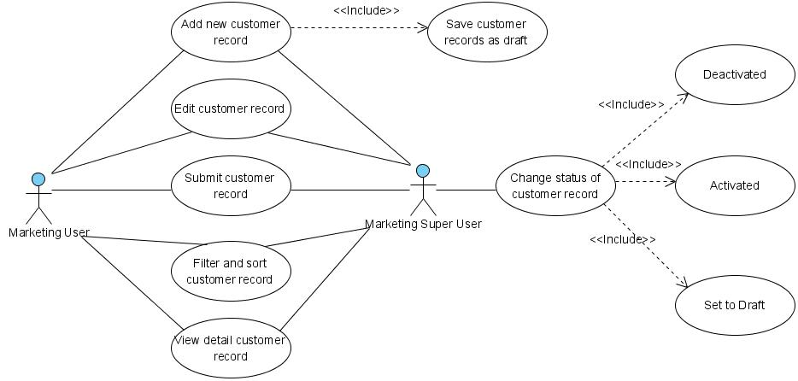

Figure 1 – Use case diagram of Customer Information

* + 1. **Operations and scenarios**

The figure below is describing operations or steps performed in a function interact with people (flow of work between users and the system).

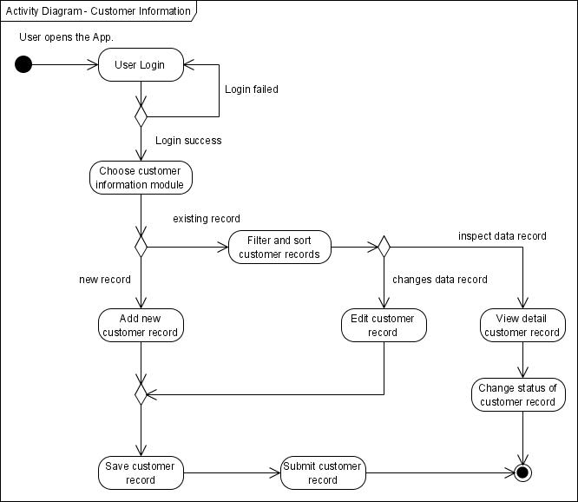

Figure 2 – Activity diagram of Customer Information

|  |  |  |  |
| --- | --- | --- | --- |
| **No.** | **Steps/ Operations** | **Actor/ People** | **Scenario** |
| 1 | Login | Marketing user, Marketing super user | * Actor fills out login form by inputting user name and password. * Actor clicks [sign in] button. System will check the account of user; if actor account is already registered user will enter into the system. If doesn’t user can return the step. |
| 2. | Choose customer information module | Marketing user, Marketing super user | * After login, actor can choose customer information module on the menu of system. After that, screen of customer information will be opens. * After customer screen opens, customer list will be shown and customer data existing will be displayed. |
| 3. | Add new customer | Marketing user, Marketing super user | * If customer information screen opens, actor can click [add] button to add new records of customer, and after that add new customer screen will be opens. * Upon add new customer screen, actor fill out the fields. * The mandatory fields cannot be blanks. |
| 4. | Save customer record | Marketing user, Marketing super user | * After fill out the fields, actor can click [save as draft] button, if want to make a records as **draft**. * After that, system will proceed to store a data into database and will be automatically check a validation of data (such like; data type, mandatory data, and data length) * If done, actor can click back button to return to the customer list, then customer data will be displayed. |
| 5 | Submit customer record | Marketing user, Marketing super user | * Once data is saved and data has been confirmed, actor can submit the record by click [submit] button. * After that system will set a supplier record as **submitted (or not draft)**. * If done, actor can click back button to return to the customer list. |
| 6. | Filter and sort customer records | Marketing user, Marketing super user | * Actor can then filter and sort the customer record based on columns where displayed on the customer list. * To filter customer records, actor can enter keywords into the filter fields. After that press enter on the keyboards. If data founds, the result will be displayed on the customer list. If doesn’t customer list will be blanks. * To sort customer records, actor can click header of column on the list table. After that the records will be sorted by ascending or descending, alternately. |
| 7. | Edit customer records | Marketing user, Marketing super user | * On the customer information screen actor can open edit customer screen to edit some kinds of data. * If there is customer record still draft, *marketing user* can click [edit] button on the right side of the records on the customer information list. * If there is customer record already submits and the status is **active**, *marketing user* cannot click [edit] button to open edit customer screen. Only, *marketing super user* can edit customer record with status is **active** or **inactive**. * To edit data of customer and if edit customer screen opens, actor can edit a record by inputting a data on each of the fields. * The mandatory fields cannot be blanks. |
| 8. | View detail customer record | Marketing user, Marketing super user | * On the customer information screen actor can open view detail customer screen to inspect a data. * To view detail customer record, click [view detail] button, after that system will displayed a screen of view detail customer. * On this screen, actor cannot do something to edit of data. Only view detail of customer record. |
| 9 | Change status of customer record | Marketing super user | * If view detail customer screen opens, actor can change the status of customer by click of [activated] button or [deactivated] button (depending by status that needs to change). * If marketing super user want to data should be edited by user, then records can be [set to draft] * After that, system will proceed automatically to change the status. * If status of customer record is **active**, then [activated] will be visible. And opposite that, if status of customer record is **inactive**, then [deactivated] will be visible. In short, one of them will be visible or invisible. * If done, actor can click back button to return to the customer list. |

* + 1. **Status management and roles**

The figure below is describing a role matrix (including relation with Status) of actor that already identified in a function.

|  |  |  |  |  |  |  |  |
| --- | --- | --- | --- | --- | --- | --- | --- |
| **Role of Actor** | **Filter and sort** | **Save as draft** | **Save changes**  **(draft)** | **Save changes**  **(active)** | **Submit** | **Activated** | **Deactivated** |
| Marketing super user | Yes | Yes | Yes | Yes | Yes | Yes | Yes |
| Marketing user | Yes | Yes | Yes | No | Yes | No | No |

The figure below is describing workflow of Status that performed when people interact in a function.

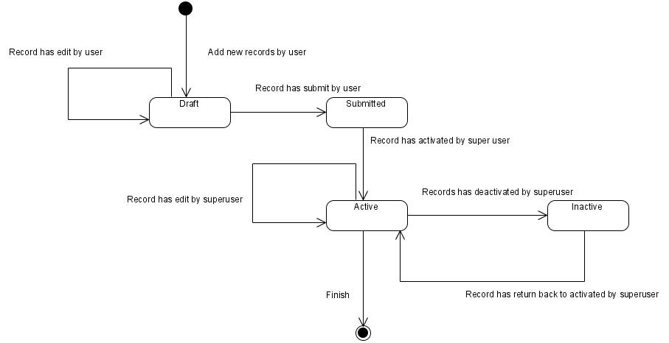

Figure 3 – Status diagram of Customer Information

* + 1. **Sitemap design**

Describe a web page that lists the pages on a web site to users. Usually sitemap organized in hierarchical style.

Figure 4 – Sitemap design of customer information page

* + 1. **Screen design**
       1. **Customer information**

This screen is designed to display a customer list. On the customer list user can filter and sort a customer records. And also, user can open another screen to add new customer record, edit customer record, and view detail of customer record.

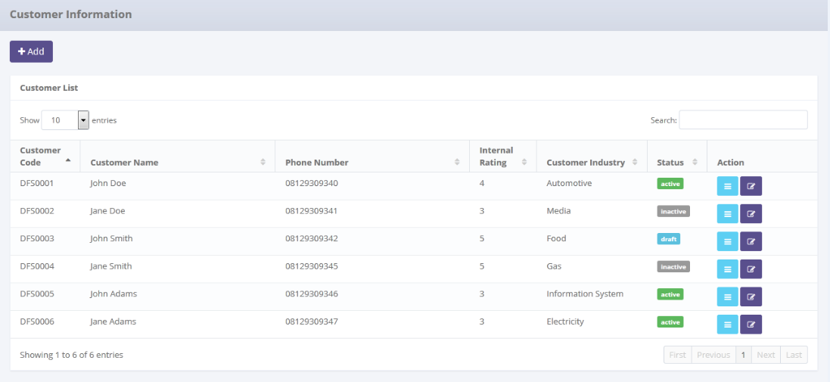

Data paging information

To open paging of customer records

To filter customer record

To open edit or view detail customer

To open add new customer pages

To filter a number of record filter button

Displaying customer list

Image 1 – Screen of Customer Information

* + - 1. **Add new customer record**

This screen is designed to entry a new customer record. After fill out some data at the screen, user can stored a data into the system by click the action button.

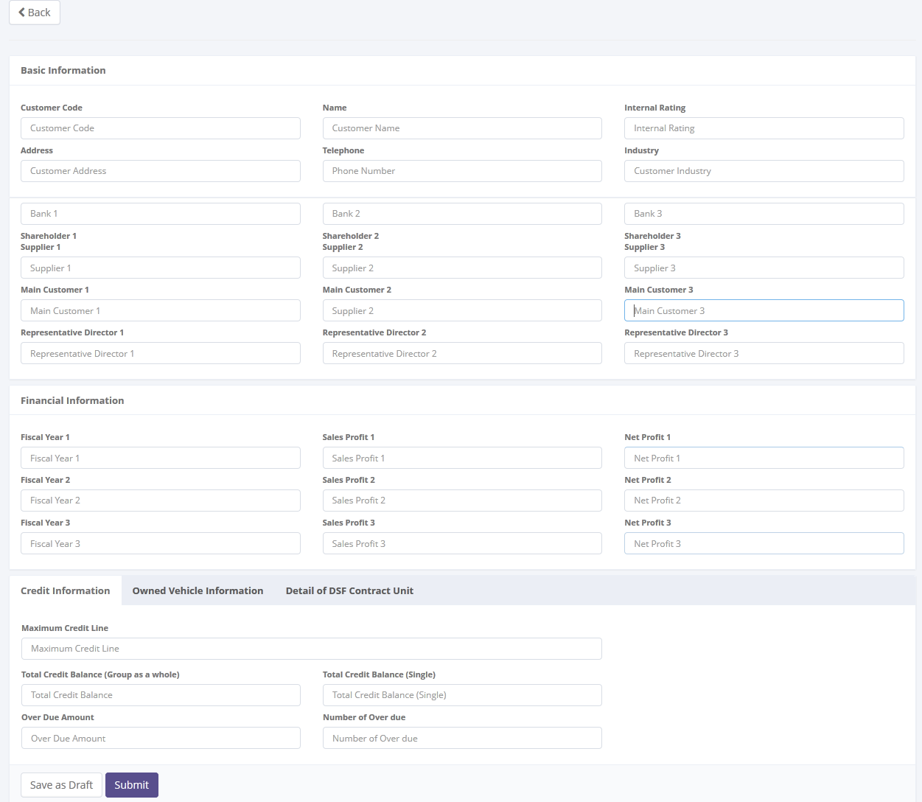

To save or submit of data

To entry a data of customer

Return back to customer list

Image 2 – Screen of add new customer record

* + - 1. **Edit customer record**

This screen is designed to edit customer record. After changes some data at the screen, user can stored a data into the system by click the action button.

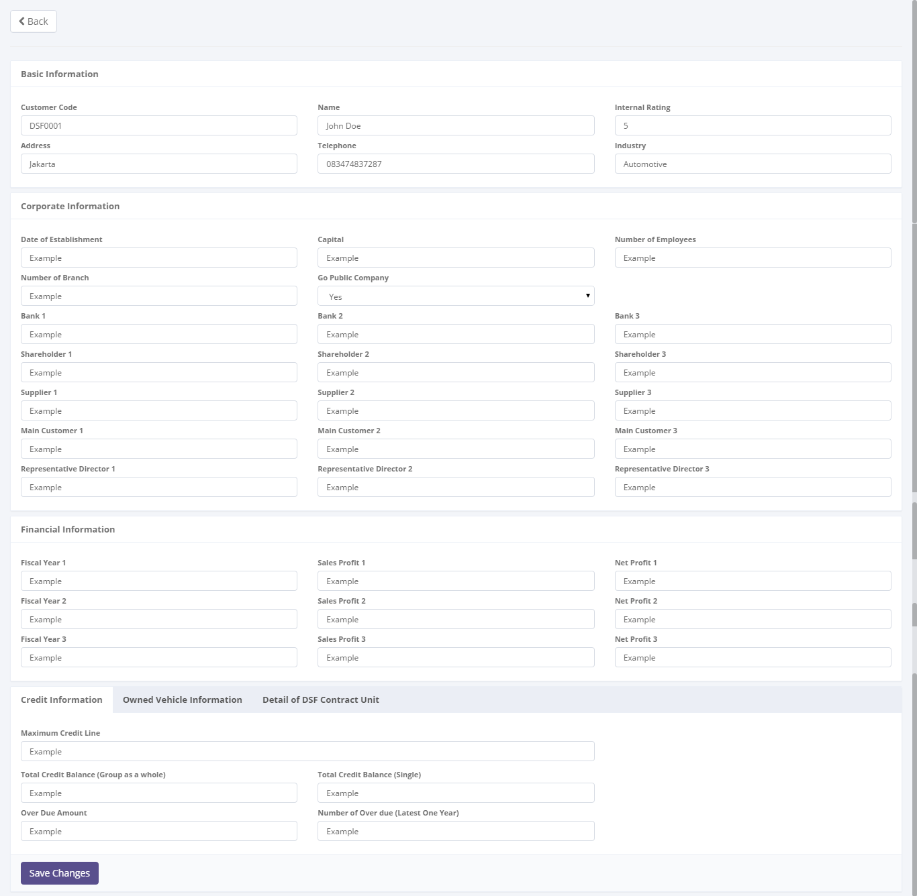

To save or submit of data

Entry data form

Return back to customer list

Image 3 – Screen of edit customer record

* + - 1. **View detail customer record**

This screen is designed to view detail a customer record. On this screen user can changes status of a customer record by click action button.

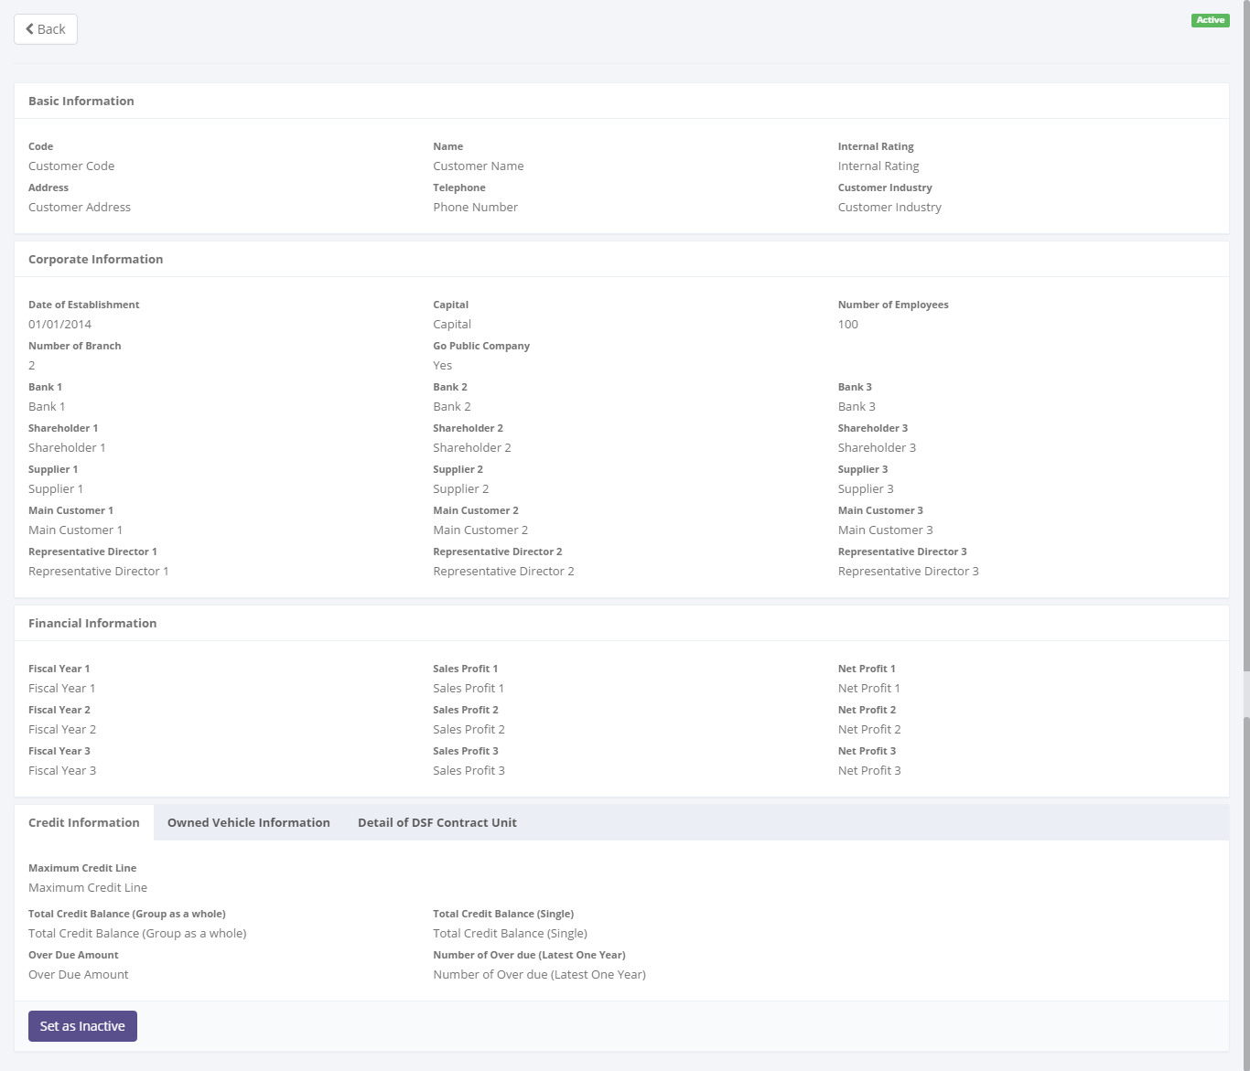

To changes a status of customer record

Detail information of customer

Status of customer record

Return back to customer list

Image 4 – Screen of view detail customer record

* + 1. **Screen features**

|  |  |
| --- | --- |
| **Features** | **Description** |
| [Filter and sort] | To perform data filter and data sort of product records. |
| [Add new] | To add new customer record by fill out add new form. |
| [Save as draft] or [Set to draft] | To save a new customer record as a draft. |
| [Submit] | To submit a customer record as a final. |
| [Save changes] | To update of changes when editing customer record. |
| [View detail] | To inspect a detail customer records by opens a detail form of customer. |
| [Edit] | To edit of customer record. |
| [Activated] | To return back of status of customer record as active. |
| [Deactivated] | To set a status of customer record as inactive |

* + 1. **Data structure**

|  |  |  |  |  |
| --- | --- | --- | --- | --- |
| **Field** | **Data Type** | **Data Length** | **Format** | **Mandatory** |
| Customer Id | Text | 10 | N/A | *Yes* |
| Name | Text | 200 | N/A | *Yes* |
| Address | Text | 200 | N/A | *Yes* |
| Telephone | Number | 15 | N/A | *Yes* |
| Internal rating | Number | 10 | N/A | *No* |
| Business sector economy | Text | 100 | N/A | *Yes* |
| Date of establishment | Date | N/A | dd-mm-yyyy | *No* |
| Capital | Text | 200 | N/A | *No* |
| Number of employee | Text | 200 | N/A | *No* |
| Branch number | Number | 10 | N/A | *No* |
| Go public company | Yes/ NO | N/A | N/A | *No* |
| Maximum credit line | Currency | 18 | ###,###,###.## | *No* |
| Total cost balance group | Currency | 18 | ###,###,###.## | *No* |
| Total cost balance single | Currency | 18 | ###,###,###.## | *No* |
| Overdue amount | Currency | 18 | ###,###,###.## | *No* |
| Overdue number | Numeric | 10 | N/A | *No* |
| Customer vehicle unit | Number | 10 | N/A | *No* |
| DSF vehicle unit | Number | 10 | N/A | *No* |
| Potential vehicle unit | Number | 10 | N/A | *No* |
| Information acquisition date vehicle unit | Date | N/A | dd-mm-yyyy | *No* |
| Customer forklift unit | Number | 10 | N/A | *No* |
| DSF forklift unit | Number | 10 | N/A | *No* |
| Potential forklift unit | Number | 10 | N/A | *No* |
| Information acquisition date forklift unit | Date | N/A | dd-mm-yyyy | *No* |
| Customer HE unit | Number | 10 | N/A | *No* |
| DSF HE unit | Number | 10 | N/A | *No* |
| Potential HE unit | Number | 10 | N/A | *No* |
| Information acquisition date HE unit | Date | N/A | dd-mm-yyyy | *No* |
| LCV non maintenance | Number | 18 | N/A | *No* |
| LCV maintenance | Number | 18 | N/A | *No* |
| LCV CSD | Number | 18 | N/A | *No* |
| LCV finance lease | Currency | 18 | ###,###,###.## | *No* |
| CV non maintenance | Number | 18 | N/A | *No* |
| CV maintenance | Number | 18 | N/A | *No* |
| CV CSD | Number | 18 | N/A | *No* |
| CV finance lease | Currency | 18 | ###,###,###.## | *No* |
| PC non maintenance | Number | 18 | N/A | *No* |
| PC maintenance | Number | 18 | N/A | *No* |
| PC CSD | Number | 18 | N/A | *No* |
| PC finance lease | Currency | 18 | ###,###,###.## | *No* |
| Forklift non maintenance | Number | 18 | N/A | *No* |
| Forklift maintenance | Number | 18 | N/A | *No* |
| Forklift CSD | Number | 18 | N/A | *No* |
| Forklift finance lease | Currency | 18 | ###,###,###.## | *No* |
| HE non maintenance | Number | 18 | N/A | *No* |
| HE maintenance | Number | 18 | N/A | *No* |
| HE CSD | Number | 18 | N/A | *No* |
| HE finance lease | Currency | 18 | ###,###,###.## | *No* |
| IsDraft | YES/NO | N/A | N/A | *Yes* |
| IsActive | YES/NO | N/A | N/A | *Yes* |
| IsSubmit | YES/NO | N/A | N/A | *Yes* |
| Remarks | Text | 200 | N/A | *No* |
| **Customer Detail Info** | | | | |
| Bank | Text | 100 | N/A | *No* |
| Shareholder | Text | 100 | N/A | *No* |
| Main Vendor | Text | 100 | N/A | *No* |
| Main Customer | Text | 100 | N/A | *No* |
| Representative Director | Text | 100 | N/A | *No* |
| Fiscal Year | Text | 100 | N/A | *No* |
| Sales Profit | Number | 10 | N/A | *No* |
| Net Profit | Number | 10 | N/A | *No* |
| Remarks | Text | 200 | N/A | *No* |

* 1. Supplier information
     1. **Use case**

The figure below is summarizing who uses features of function, and what they can do with it.

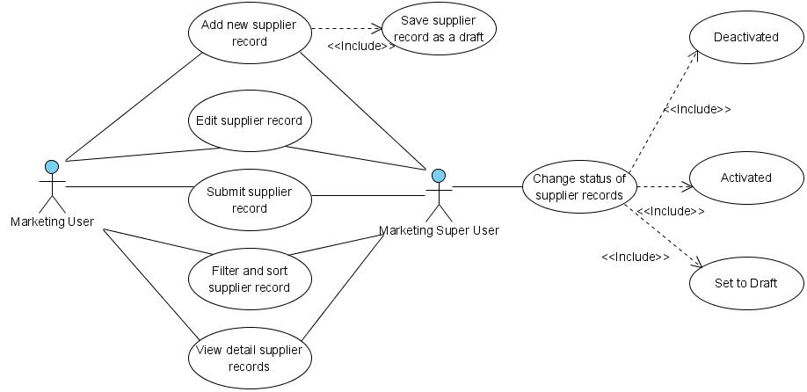

Figure 5 – Use case diagram of Supplier Information

* + 1. **Operations and scenarios**

The figure below is describing operations or steps performed in a function interact with people (flow of work between users and the system).

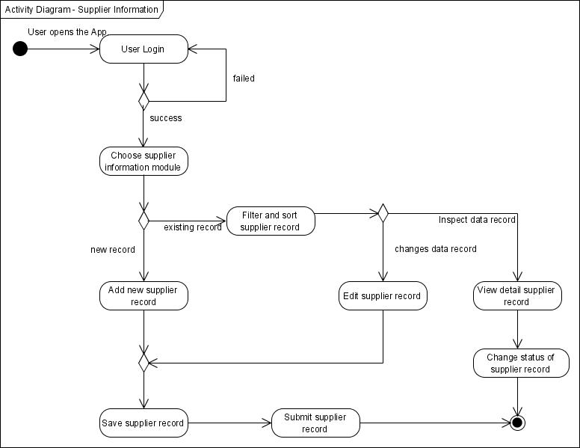

Figure 6 – Activity diagram of Supplier Information

|  |  |  |  |
| --- | --- | --- | --- |
| **No.** | **Steps/ Operations** | **Actor/ People** | **Scenario** |
| 1 | Login | Marketing user, Marketing super user | * Actor fills out login form by inputting user name and password. * Actor clicks [sign in] button. System will check the account of user; if actor account is already registered user will enter into the system. If doesn’t user can return the step. |
| 2. | Choose supplier information module | Marketing user, Marketing super user | * After login, actor can choose supplier information module on the menu of system. After that, screen of supplier information will be opens. * After supplier screen opens, supplier list will be shown and supplier data existing will be displayed. |
| 3. | Add new supplier | Marketing user, Marketing super user | * If supplier information screen opens, actor can click [add] button to add new records of supplier, and after that add new supplier screen will be opens. * Upon add new supplier screen, actor fill out the fields. * The mandatory fields cannot be blanks. |
| 4. | Save supplier record | Marketing user, Marketing super user | * After fill out the fields, actor can click [save as draft] button, if want to make a records as **draft**. * After that, system will proceed to store a data into database and will be automatically check a validation of data (such like; data type, mandatory data, and data length) * If done, actor can click back button to return to the supplier list, then supplier data will be displayed. |
| 5 | Submit supplier record | Marketing user, Marketing super user | * Once data is saved and data has been confirmed, actor can submit the record by click [submit] button. * After that system will set a supplier record as **submitted (or not draft)**. * If done, actor can click back button to return to the supplier list. |
| 6. | Filter and sort supplier records | Marketing user, Marketing super user | * Actor can then filter and sort the supplier record based on columns where displayed on the supplier list. * To filter supplier records, actor can enter keywords into the filter fields. After that press enter on the keyboards. If data founds, the result will be displayed on the supplier list. If doesn’t supplier list will be blanks. * To sort supplier records, actor can click header of column on the list table. After that the records will be sorted by ascending or descending, alternately. |
| 7. | Edit supplier records | Marketing user, Marketing super user | * On the supplier information screen actor can open edit supplier screen to edit some kinds of data. * If there is supplier record still draft, *marketing user* can click [edit] button on the right side of the records on the supplier information list. * If there is supplier record already submits and the status is **active**, *marketing user* cannot click [edit] button to open edit supplier screen. Only, *marketing super user* can edit supplier record with status is **active** or **inactive**. * To edit data of supplier and if edit supplier screen opens, actor can edit a record by inputting a data on each of the fields. * The mandatory fields cannot be blanks. |
| 8. | View detail supplier record | Marketing user, Marketing super user | * On the supplier information screen actor can open view detail supplier screen to inspect a data. * To view detail supplier record, click [view detail] button, after that system will displayed a screen of view detail supplier. * On this screen, actor cannot do something to edit of data. Only view detail of supplier record. |
| 9 | Change status of supplier record | Marketing super user | * If view detail supplier screen opens, actor can change the status of supplier by click of [activated] button or [deactivated] button (depending by status that needs to change). * If marketing super user want to data should be edited by user, then records can be [set to draft] * After that, system will proceed automatically to change the status. * If status of supplier record is **active**, then [activated] will be visible. And opposite that, if status of supplier record is **inactive**, then [deactivated] will be visible. In short, one of them will be visible or invisible. * If done, actor can click back button to return to the supplier list. |

* + 1. **Status management and roles**

The figure below is describing a role matrix (including relation with Status) of actor that already identified in a function.

|  |  |  |  |  |  |  |  |
| --- | --- | --- | --- | --- | --- | --- | --- |
| **Role of Actor** | **Filter and sort** | **Save as draft** | **Save changes**  **(draft)** | **Save changes**  **(active)** | **Submit** | **Activated** | **Deactivated** |
| Marketing super user | Yes | Yes | Yes | Yes | Yes | Yes | Yes |
| Marketing user | Yes | Yes | Yes | No | Yes | No | No |

The figure below is describing workflow of Status that performed when people interact in a function.



Figure 7 – Status diagram of Supplier Information

* + 1. **Sitemap design**

Describe a web page that lists the pages on a web site to users. Usually sitemap organized in hierarchical style.

Figure 8 – Sitemap design of supplier information page

* + 1. **Screen design**
       1. **Supplier information**

This screen is designed to display a supplier list. On the supplier list user can filter and sort a supplier records. And also, user can open another screen to add new supplier record, edit supplier record, and view detail of supplier record.

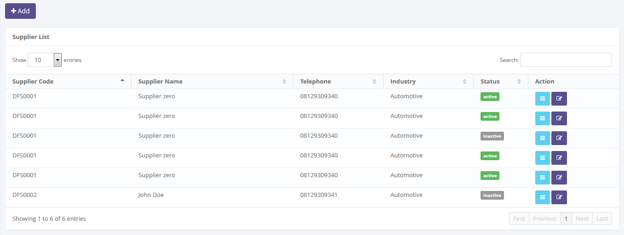

To open edit or view detail supplier

Displaying supplier list

To open paging of supplier records

Data paging information

To filter supplier record

To filter a number of record filter button

To open add new supplier pages

Image 5 – Screen of supplier information

* + - 1. **Add new supplier record**

This screen is designed to entry a new supplier record. After fill out some data at the screen, user can stored a data into the system by click the action button.

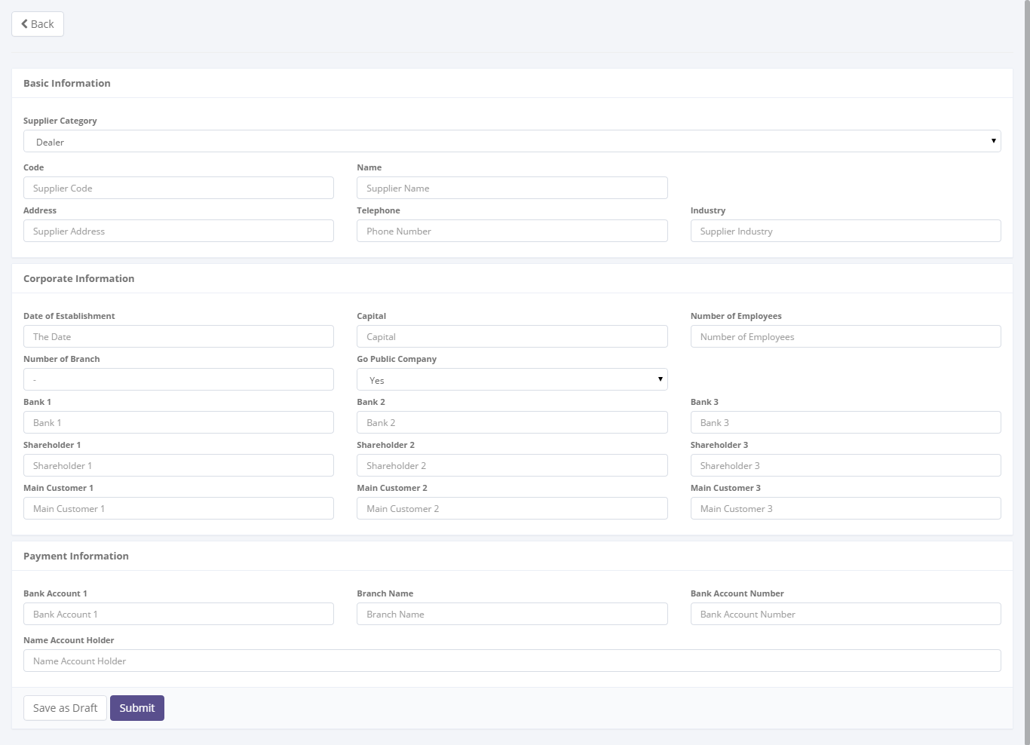

To save or submit of data

To entry a data of supplier

Return back to supplier list

Image 6 – Screen of add new supplier record

* + - 1. **Edit supplier record**

This screen is designed to edit supplier record. After changes some data at the screen, user can stored a data into the system by click the action button.

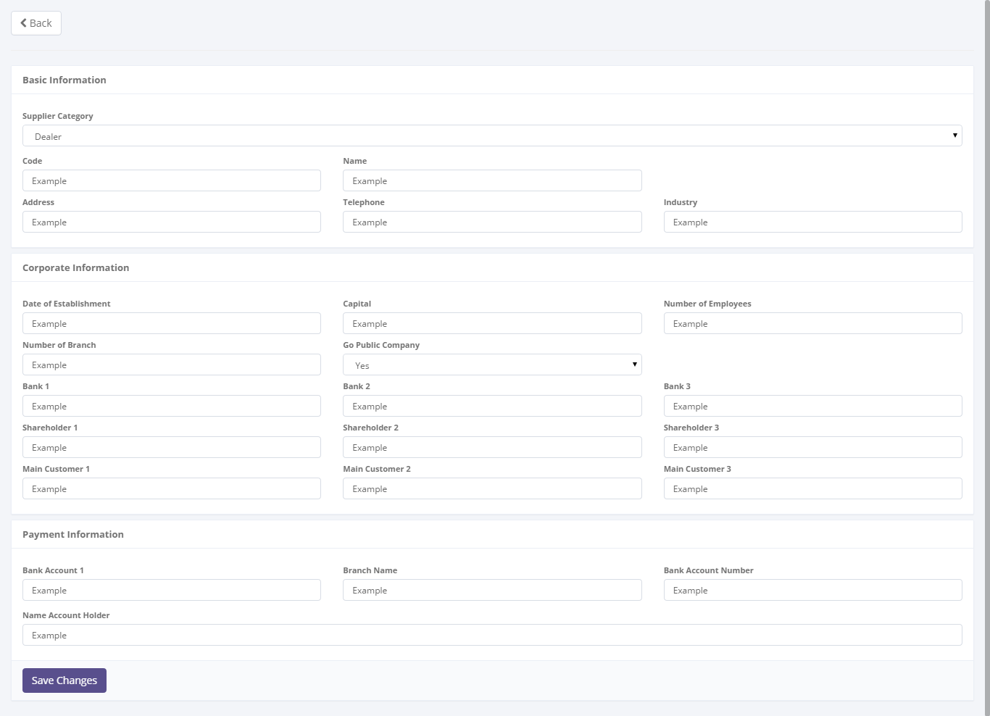

Return back to supplier list

To save or submit of data

Entry data form

Image 7 – Screen of edit supplier record

* + - 1. **View detail supplier record**

This screen is designed to view detail a supplier record. On this screen user can changes status of a supplier record by click action button.

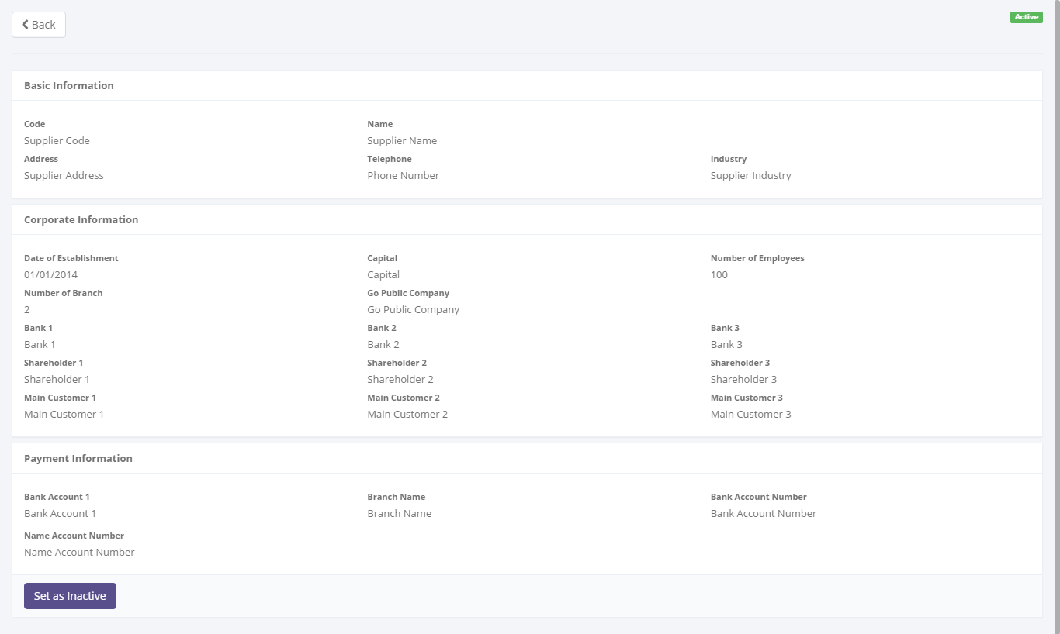

To changes a status of supplier record

Detail information of supplier

Return back to supplier list

Status of supplier record

Image 8 – Screen of view detail supplier record

* + 1. **Screen features**

|  |  |
| --- | --- |
| **Features** | **Description** |
| [Filter and sort] | To perform data filter and data sort of product records. |
| [Add new] | To add new supplier record by fill out add new form. |
| [Save as draft] or  [Set to draft] | To save a new supplier record as a draft. |
| [Submit] | To submit a supplier record as a final. |
| [Save changes] | To update of changes when editing supplier record. |
| [View detail] | To inspect a detail supplier records by opens a detail form of supplier. |
| [Edit] | To edit of supplier record. |
| [Activated] | To return back of status of supplier record as active. |
| [Deactivated] | To set a status of supplier record as inactive |

* + 1. **Data structure**

|  |  |  |  |  |  |
| --- | --- | --- | --- | --- | --- |
| **Field** | **Data Type** | **Data Length** | **Format** | **Mandatory** | |
| Supplier Category | Text | 200 | N/A | *Yes* | |
| Supplier Group Code | Text | 100 | N/A | *Yes* | |
| Supplier Group Name | Text | 200 | N/A | *Yes* | |
| Supplier Code | Text | 100 | N/A | *Yes* | |
| Supplier Name | Text | 200 | N/A | *Yes* | |
| Address | Text | Max | N/A | *Yes* | |
| Telephone | Text | 15 | N/A | *Yes* | |
| Business Economy Sector | Text | 200 | N/A | *Yes* | |
| Establishment Date | Date | N/A | dd-mm-yyyy | *No* | |
| Capital | Text | 100 | N/A | *No* | |
| Number of employee | Text | 200 | N/A | *No* | |
| Number of Branch | Number | 10 | N/A | *No* | |
| Go Public Company | YES/NO | N/A | N/A | *No* | |
| IsDraft | YES/NO | N/A | N/A | *Yes* | |
| IsActive | YES/NO | N/A | N/A | *Yes* | |
| IsSubmit | YES/NO | N/A | N/A | *Yes* | |
| Remarks | Text | 200 | N/A | *No* | |
| **Supplier Corporate Info** | | | | | |
| Bank Name | Text | 100 | N/A | | *No* |
| Shareholder | Text | 100 | N/A | | *No* |
| Main Customer | Text | 100 | N/A | | *No* |
| **Supplier Payment Info** | | | | | |
| Bank Account | Text | 100 | N/A | | *No* |
| Branch Name | Text | 100 | N/A | | *No* |
| Bank Account Number | Text | 100 | N/A | | *No* |
| Name Account Holder | Text | 100 | N/A | | *No* |

* 1. Product information
     1. **Use case**

The figure below is summarizing who uses features of function, and what they can do with it.

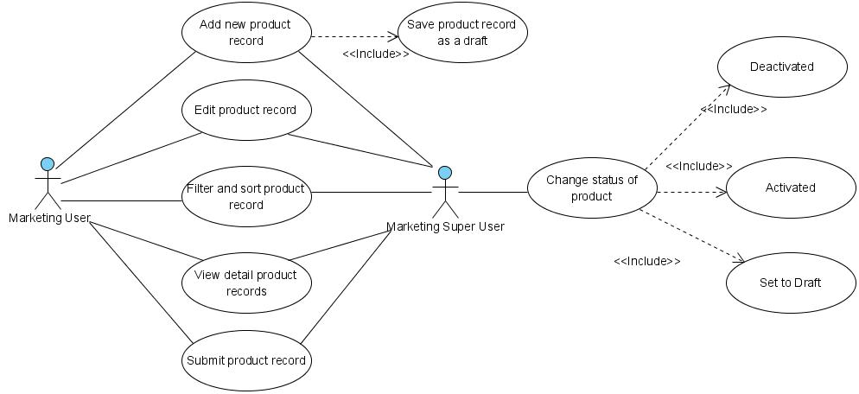

Figure 9 – Use case diagram of Product Information

* + 1. **Operations and scenarios**

The figure below is describing operations or steps performed in a function interact with people (flow of work between users and the system).

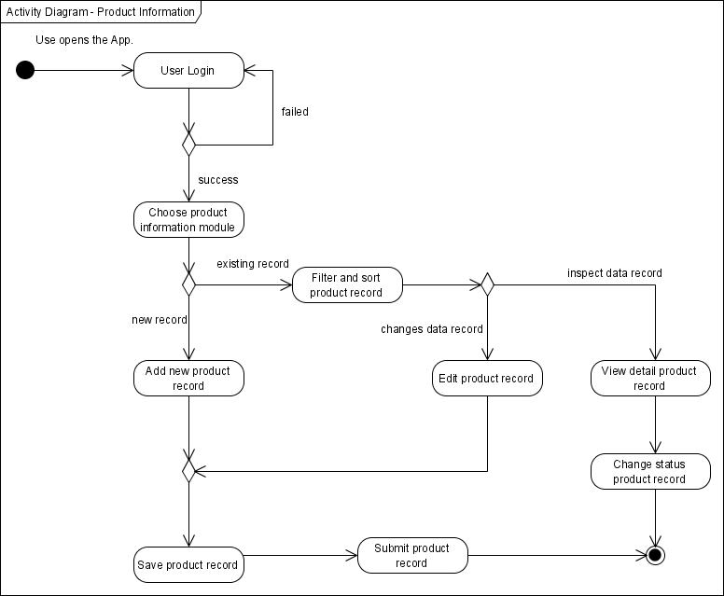

Figure 10 – Activity diagram of Product Information

|  |  |  |  |
| --- | --- | --- | --- |
| **No.** | **Steps/ Operations** | **Actor/ People** | **Scenario** |
| 1 | Login | Marketing user, Marketing super user | * Actor fills out login form by inputting user name and password. * Actor clicks [sign in] button. System will check the account of user; if actor account is already registered user will enter into the system. If doesn’t user can return the step. |
| 2. | Choose product information module | Marketing user, Marketing super user | * After login, actor can choose product information module on the menu of system. After that, screen of product information will be opens. * After product screen opens, product list will be shown and product data existing will be displayed. |
| 3. | Add new product | Marketing user, Marketing super user | * If product information screen opens, actor can click [add] button to add new records of product, and after that add new product screen will be opens. * Upon add new product screen, actor fill out the fields. * The mandatory fields cannot be blanks. |
| 4. | Save product record | Marketing user, Marketing super user | * After fill out the fields, actor can click [save as draft] button, if want to make a records as **draft**. * After that, system will proceed to store a data into database and will be automatically check a validation of data (such like; data type, mandatory data, and data length) * If done, actor can click back button to return to the product list, then product data will be displayed. |
| 5 | Submit product record | Marketing user, Marketing super user | * Once data is saved and data has been confirmed, actor can submit the record by click [submit] button. * After that system will set a supplier record as **submitted (or not draft)**. * If done, actor can click back button to return to the product list. |
| 6. | Filter and sort product records | Marketing user, Marketing super user | * Actor can then filter and sort the product record based on columns where displayed on the product list. * To filter product records, actor can enter keywords into the filter fields. After that press enter on the keyboards. If data founds, the result will be displayed on the product list. If doesn’t product list will be blanks. * To sort product records, actor can click header of column on the list table. After that the records will be sorted by ascending or descending, alternately. |
| 7. | Edit product records | Marketing user, Marketing super user | * On the product information screen actor can open edit product screen to edit some kinds of data. * If there is product record still draft, *marketing user* can click [edit] button on the right side of the records on the product information list. * If there is product record already submits and the status is **active**, *marketing user* cannot click [edit] button to open edit product screen. Only, *marketing super user* can edit product record with status is **active** or **inactive**. * To edit data of product and if edit product screen opens, actor can edit a record by inputting a data on each of the fields. * The mandatory fields cannot be blanks. |
| 8. | View detail product record | Marketing user, Marketing super user | * On the product information screen actor can open view detail product screen to inspect a data. * To view detail product record, click [view detail] button, after that system will displayed a screen of view detail product. * On this screen, actor cannot do something to edit of data. Only view detail of product record. |
| 9 | Change status of product record | Marketing super user | * If view detail product screen opens, actor can change the status of product by click of [activated] button or [deactivated] button (depending by status that needs to change). * If marketing super user want to data should be edited by user, then records can be [set to draft] * After that, system will proceed automatically to change the status. * If status of product record is **active**, then [activated] will be visible. And opposite that, if status of product record is **inactive**, then [deactivated] will be visible. In short, one of them will be visible or invisible. * If done, actor can click back button to return to the product list. |

* + 1. **Status management and roles**

The figure below is describing a role matrix (including relation with Status) of actor that already identified in a function.

|  |  |  |  |  |  |  |  |
| --- | --- | --- | --- | --- | --- | --- | --- |
| **Role of Actor** | **Filter and sort** | **Save as draft** | **Save changes**  **(draft)** | **Save changes**  **(active)** | **Submit** | **Activated** | **Deactivated** |
| Marketing super user | Yes | Yes | Yes | Yes | Yes | Yes | Yes |
| Marketing user | Yes | Yes | Yes | No | Yes | No | No |

The figure below is describing workflow of Status that performed when people interact in a function.



Figure 11 – Status diagram of Product Information

* + 1. **Sitemap design**

Describe a web page that lists the pages on a web site to users. Usually sitemap organized in hierarchical style.

Figure 12 – Sitemap design of product information page

* + 1. **Screen design**
       1. **Product information**

This screen is designed to display a product list. On the product list user can filter and sort a product records. And also, user can open another screen to add new product, edit product record, and view detail of product record.

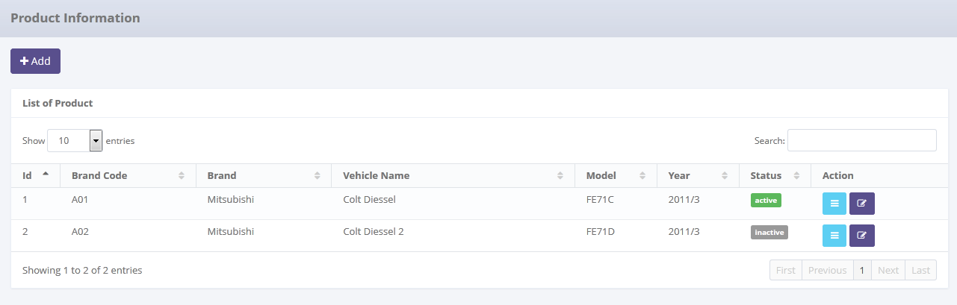

To filter product record

To open edit or view detail product

Displaying product list

To filter a number of record filter button

To open paging of product records

Data paging information

To open add new product pages

Image 9 – Screen of product information

* + - 1. **Add new product record**

This screen is designed to entry a new product record. After fill out some data at the screen, user can stored a data into the system by click the action button.

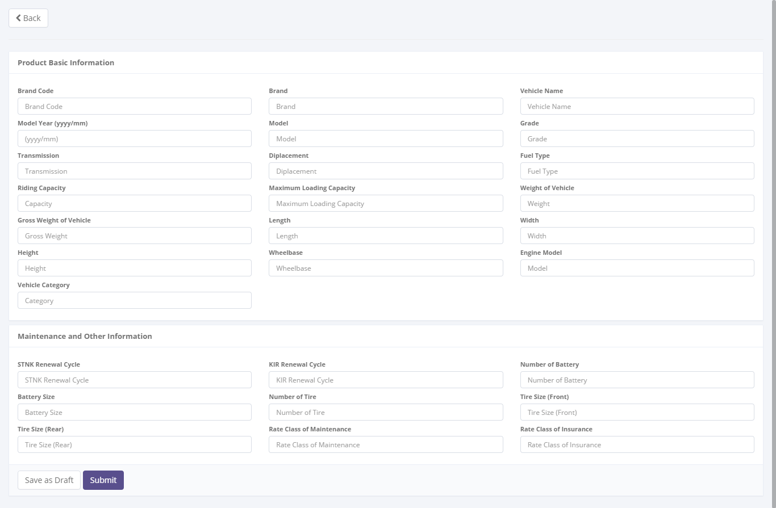

To save or submit of data

Return back to product list

To entry a data of product

Image 10 – Screen of add new product record

* + - 1. **Edit product record**

This screen is designed to edit product record. After changes some data at the screen, user can stored a data into the system by click the action button.

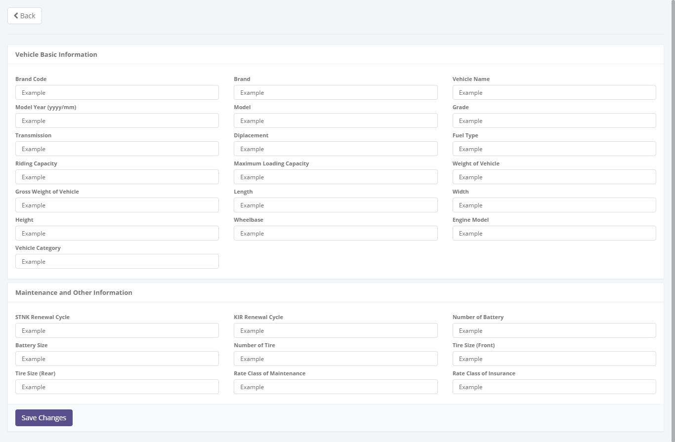

To save or submit of data

Return back to product list

Entry data form

Image 11 – Screen of edit product record

* + - 1. **View detail product record**

This screen is designed to view detail a product record. On this screen user can changes status of a product record by click action button.

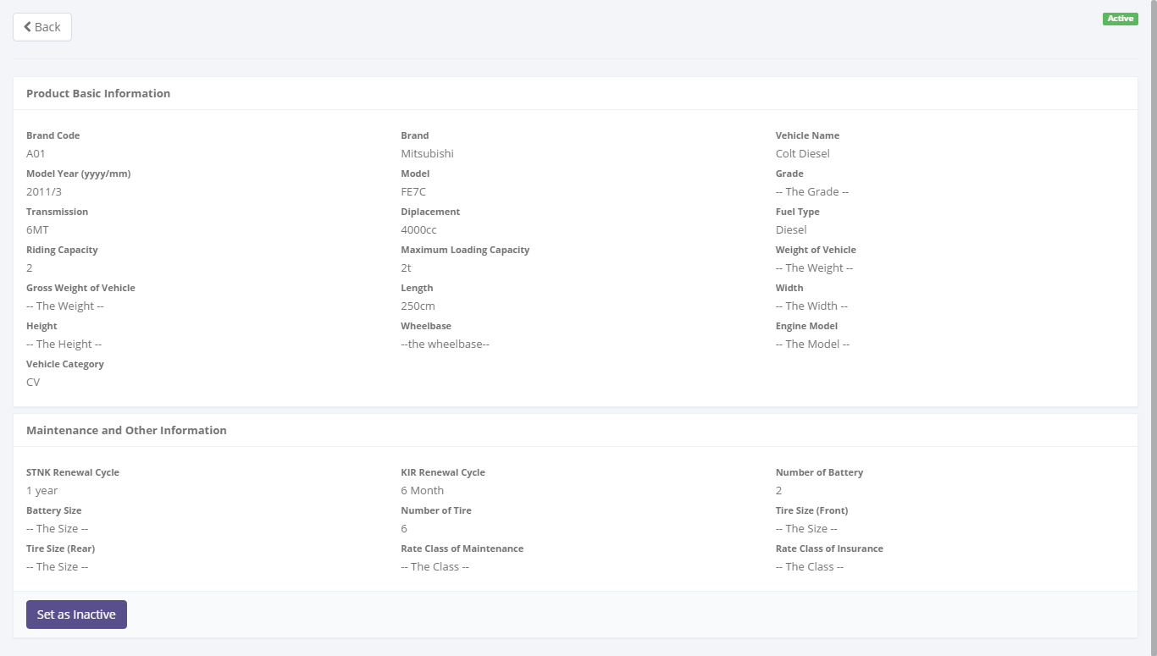

To changes a status of product record

Detail information of product

Return back to product list

Status of product record

Image 12 – Screen of view detail product record

* + 1. **Screen features**

|  |  |
| --- | --- |
| **Features** | **Description** |
| [Filter and sort] | To perform data filter and data sort of product records. |
| [Add new] | To add new product record by fill out add new form. |
| [Save as draft] or  [Set to draft] | To save a new product record as a draft. |
| [Submit] | To submit a product record as a final. |
| [Save changes] | To update of changes when editing product record. |
| [View detail] | To inspect a detail product records by opens a detail form of product. |
| [Edit] | To edit of product record. |
| [Activated] | To return back of status of product record as active. |
| [Deactivated] | To set a status of product record as inactive |

* + 1. **Data structure**

|  |  |  |  |  |
| --- | --- | --- | --- | --- |
| **Field** | **Data Type** | **Data Length** | **Format** | **Mandatory** |
| Product Type | Text | 100 | N/A | *Yes* |
| Product Category | Text | 100 | N/A | *Yes* |
| Product Name | Text | 100 | N/A | *Yes* |
| Brand Code | Text | 100 | N/A | *Yes* |
| Brand Name | Text | 100 | N/A | *Yes* |
| Model Code | Text | 100 | N/A | *Yes* |
| Model Name | Text | 100 | N/A | *Yes* |
| Model Type | Text | 100 | N/A | *Yes* |
| Model Year | Date | N/A | mm-yyyy | *Yes* |
| Grade | Text | 100 | N/A | *No* |
| Transmission | Text | 100 | N/A | *No* |
| Displacement | Text | 100 | N/A | *No* |
| Fuel Type | Text | 200 | N/A | *No* |
| Riding Capacity | Number | 10 | N/A | *No* |
| Max Loading Capacity | Text | 50 | N/A | *No* |
| Vehicle Weight | Text | 600 | N/A | *No* |
| Gross Vehicle Weight | Text | 100 | N/A | *No* |
| Length | Text | 100 | N/A | *No* |
| Width | Text | 100 | N/A | *No* |
| Height | Text | 100 | N/A | *No* |
| Wheelbase | Text | 100 | N/A | *No* |
| Engine Model | Text | 100 | N/A | *No* |
| STNK Renewal Cycle | Text | 200 | N/A | *No* |
| KIR Renewal Cycle | Text | 100 | N/A | *No* |
| Number of Battery | Number | 10 | N/A | *No* |
| Battery Size | Text | 50 | N/A | *No* |
| Number of Tire | Text | 100 | N/A | *No* |
| Front Tire Size | Text | 200 | N/A | *No* |
| Rear Tire Size | Text | 200 | N/A | *No* |
| Maintenance Rate Class | Text | 100 | N/A | *No* |
| Insurance Rate Class | Text | 100 | N/A | *No* |
| IsDraft | YES/NO | N/A | N/A | *Yes* |
| IsActive | YES/NO | N/A | N/A | *Yes* |
| IsSubmit | YES/NO | N/A | N/A | *Yes* |
| Remarks | Text | 200 | N/A | *No* |

1. Appendix

|  |
| --- |
| ***What is the use case?***   1. ***A use case is*** *a written description of how users will perform tasks on your website.  It outlines, from a user’s point of view, a system’s behavior as it responds to a request. Each use case is represented as a sequence of simple steps, beginning with a user's goal and ending when that goal is fulfilled. (*[*http://www.usability.gov/how-to-and-tools/methods/use-cases.html*](http://www.usability.gov/how-to-and-tools/methods/use-cases.html)*)* 2. ***A use case is*** *a list of steps, typically defining interactions between a role and a system. (*[*http://en.wikipedia.org/wiki/Use_case*](http://en.wikipedia.org/wiki/Use_case)*)* 3. ***A use case is*** *a formal way of representing how a business interacts with its environment. it summarized into a single picture.* ([*http://romisatriawahono.net/lecture/sad/romi-sad-05-implementation-march2014.pptx*](http://romisatriawahono.net/lecture/sad/romi-sad-05-implementation-march2014.pptx)*)*   ***What are Benefits of use cases?***   1. ***Use cases*** *add value because they help explain how the system should behave and in the process, they also help brainstorm what could go wrong.  They provide a list of goals and this list can be used to establish the cost and complexity of the system. Project teams can then negotiate which functions become*[*requirements*](http://www.usability.gov/how-to-and-tools/methods/requirements.html)*and are built.*     *(*[*http://www.usability.gov/how-to-and-tools/methods/use-cases.html*](http://www.usability.gov/how-to-and-tools/methods/use-cases.html)*)*   1. *With the help of use case diagram, you can discuss and communicate:*  * *The scenarios in which your system or application interacts with people, organizations, or external systems.* * *The goals that it helps those actors achieve.* * *The scope of your system.*   *(*[*http://msdn.microsoft.com/en-us/library/dd409432.aspx*](http://msdn.microsoft.com/en-us/library/dd409432.aspx)*)* |